# Meeting Minutes - Sat Nov 6th 2021

Attendees: Esther, Jerry, Wisam, Alec

## Notes

Machine Learning -> Database -> Dashboard

* Everyone should push only to their own branch
* If two people are working together, please reply to the first comment
* Steps to pulling and pushing
  + Switch to personal branch `git checkout <your name>`
  + Pull main edits to your branch `git pull origin main`
  + Make edits
  + Input into terminal/git bash `git status`
  + Push to your branch
  + Alec to pull to main when necessary
* Still need to decide on which machine learning model to use.

Everyone should have 5 folders in their branch. The folders should be named exactly for below.

* Data_Exploration
* Machine_Learning
* Database
* Dashboard
* Presentation
* Project_Management - Clone of Github

All questions should be asked on the group chat!!

## Questions for SHAWN

* Having some issues with Jerry’s branch and pulling it into main

**Inputs: NOC, job vacancies characteristics, date, previous vacancies**

**Outputs: Vacancies at current date**

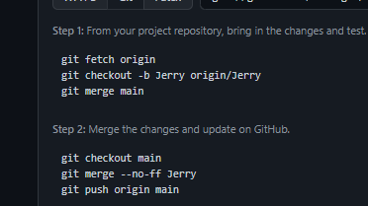

Must split data for ML, when building the features for Jan 2016 just include 2015 october, then we can do a random split.

More focus on Time series,

Regression shawn likes it since we don't need the whole history, takes in current info and predicts 6 months from now.

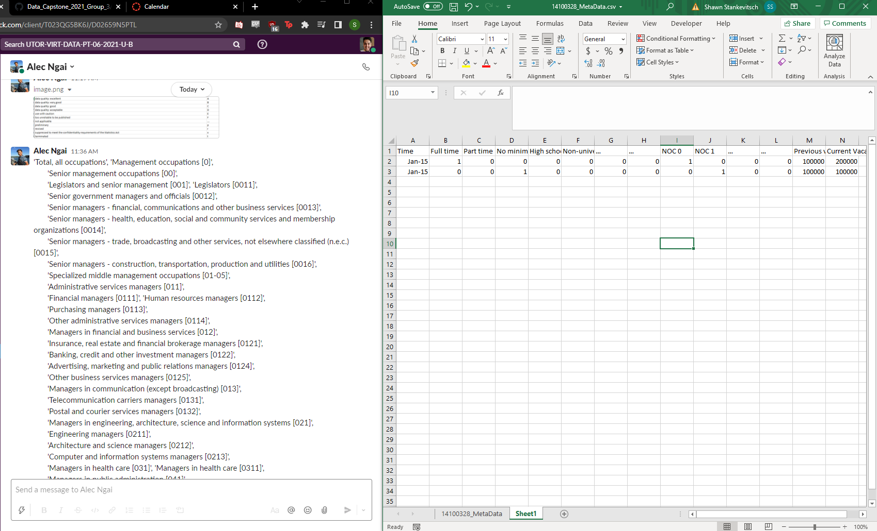

**Next Meeting Sunday Nov 7th 2021 at 10:00 AM - Wisam**